Jennifer Lavine, Liuba Buklemisheva
PRAD 585

How Do Pizza Chains Currently Utilize Twitter?

Introduction

Companies now use social media for communicating with their clients and for attracting new ones. The current work examines Twitter use among popular American pizza brands: Domino’s Pizza, Little Caesars Pizza, Papa John’s Pizza, Pizza Hut and California Pizza Kitchen. The study used content analysis method to place 100 tweets by pizza brands into one of five categories: interactivity, customer service, promotional, cross-promotional and fanship. Additionally, the tweets were also classified in two groups – containing visuals and/or video and non-containing visuals and/or video. Online social networks have changed the existing marketing model; therefore it becomes necessary to understand how this communication tool can affect the relationship between brands and consumers.

Methods

A sample of tweets was drawn directly from five pizza brands accounts (@dominos, @littlecaesars, @PapaJohns, @pizzahut, @calpizzakitchen). The most recent 20 tweets were chosen from each brand’s Twitter account. In total, 100 tweets were analyzed. The categories for coding data were determined during short discussion. Some of them were the same as in Hambrick et al. study (interactivity, promotional, fanship), while others differed. We added these categories: customer service and cross-promotional. Between these two categories we also distinguished between visual and non-visual tweets. While most categories were easy to agree on, fanship did require a little clarification as we used a separate definition from Hambrick et al.. After reviewing a few tweets that might fall under this category we were able to agree on a standard definition.

Definitions

Customer service is a companies’ professional communication with clients which is used to solve problems with product or service related to the product. Promotional, referred to the company’s self promotion of products, services, or coupons that did not come from an outside source or retweet. Cross-promotional is publicity regarding special offers made by the brand and its partner(s) or publicity which promotes events organized by brand’s partner. Interactivity, as defined by this study was when a tweet encouraged an action for the view (i.e. “watch this,” or “retweet if you like,”). Fanship refers to retweets by the company that feature a fan or customer speaking positively about the company. Tweets were then divided between visual and non-visual; visual being those that had a video or photo attached to them, while non-visual tweets did not.

Results

We found out that the majority of tweets were either promotional (27%) or cross-promotional (37%). However, the category fanship was also large (21%). Finally, 14% of tweets were interactive, and only 1% could be related to customer service category. Non-visual tweets dominated over visual tweets at 66% to 34%, a 3:1 ratio, respectively.

 | Visual | Non-Visual | Row Total
Promotional | 10 | 17 | 27
Interactive | 8 | 6 | 14
Customer Service | 0 | 1 | 1
Cross Promotion | 14 | 23 | 37
Fanship | 2 | 19 | 21
Column Total | 34 | 66 | 100

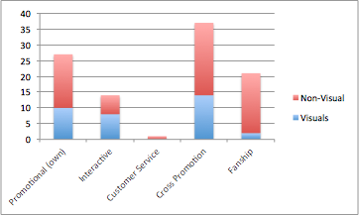* | 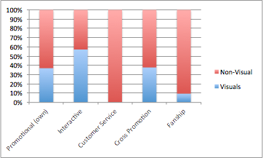*

Discussion

As we have expected, the overwhelming majority of tweets were described as promotional or cross-promotional. This means that brands use their Twitter accounts as owned media to present their services, products and special offerings. The advantages of this communication type is evident: the message doesn’t have to go through earned media filters and doesn’t cost anything in comparison to using paid media. Moreover, Twitter gives brands the opportunity to speak directly to their consumers.
Findings have shown that Twitter provides a more personalized, unfiltered method of communication used by pizza brands to develop some sort of relationship between themselves and consumers. That’s why a relatively big part (14%) of tweets was described as interactive. Pizza brands use their Twitter accounts to engage consumers in different activities (i.e., contests). Likewise, 21% of tweets were classified as related to fanship category. It implies that in average every fifth tweet written by a popular pizza brand is intended to maintain relationship with loyal companies’ clients. However, only 1% of the tweets in our sample was classified as customer service. We expected this variable to be closer to 10%. The obtained result may mean that consumers rarely use Twitter to ask brands questions about services/products or to complain.
Non-visual tweets dominated over visual tweets, which is unusual for food advertisements. This may point to twitter being used limitedly as a medium. There is potential for pizza companies to expand this venue to twitter and gear their accounts to be more visual, and therefore more easily digestible to the average consumer, leading to more impressions.

Limitations

The results for customer service category might be different if our sample was bigger. Pizza chains often tweet multiple times a day, and in some cases our sample only spanned a day or two. To truly see an accurate picture multiple days may need to be seen. The more data is analyzed, the more reliable results can be obtained. In addition, the time period when the study took place overlapped with the Super Bowl, which is one of the busiest days for pizza chains and would more than certainly influence their advertising. To achieve a more full picture it would be advisable to run this study at different intervals, multiple times.

Conclusion

Future studies should investigate the interaction between pizza brands and consumers more deeply. The research can examine if other users reply to companies’ tweets or retweet them, if the brands’ followers complain on anything, ask questions or share special offerings with their friends. The results of such research can be used by brands in order to attract more followers who can become potential clients.

